Feedback

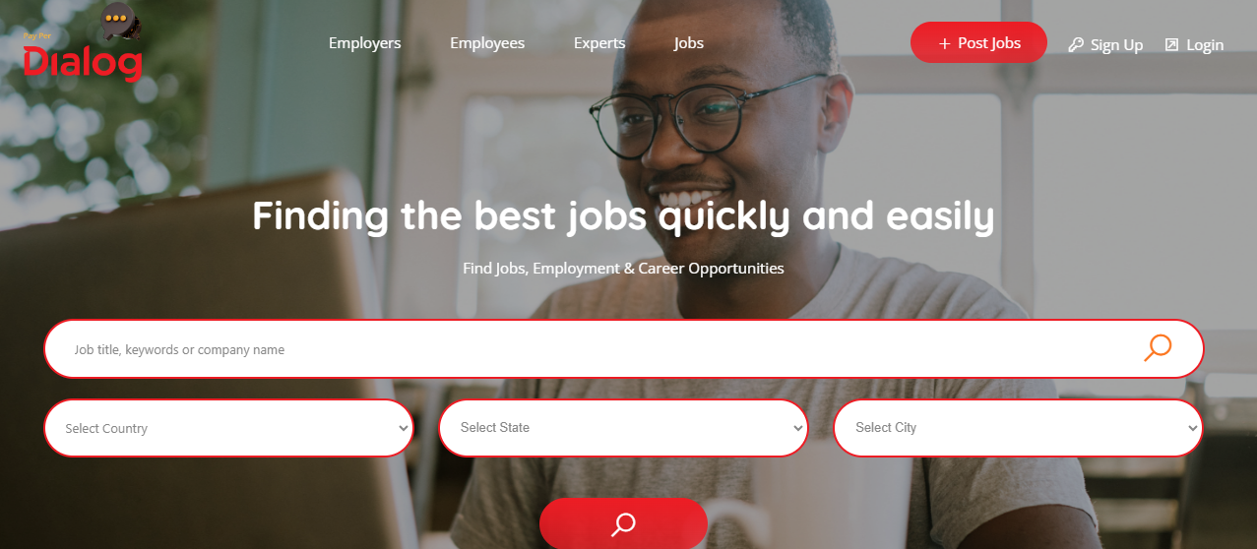

1. We can change the “employees” to “Job Seekers” 🡺 Fixed

2. When I click the Employee – it shows me a list of employees. That is incorrect if I am a job seeker myself. It should take me to a portal where I have information about my resume, my skills etc, the jobs I applied to and the interviews scheduled for me. **🡺 After Employee login, user will be able to access only “Employers” and “Jobs” tab on main menu.**

3. When I click on Employers – it shows me a list of employers. It should ideally take me to an employer portal – with jobs I posted, candidates who applied, the money I spent etc. **🡺 After Employer login, user will be able to access only “Employees” and “Expert” tab on main menu.**

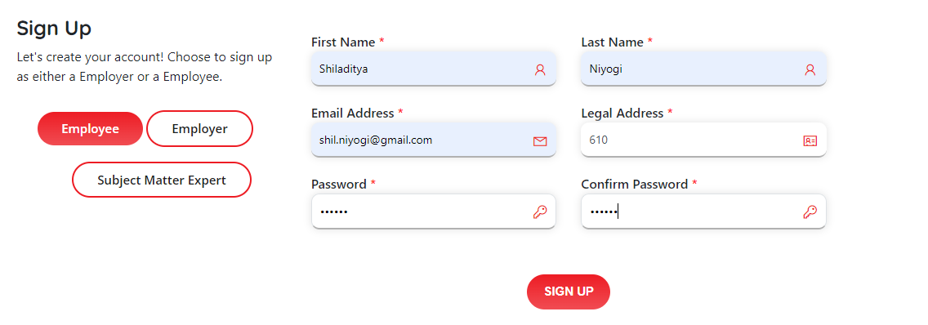

As I sign up, can we have some rules for the password (e.g. alphanumeric and special keys) 🡺 Fixed

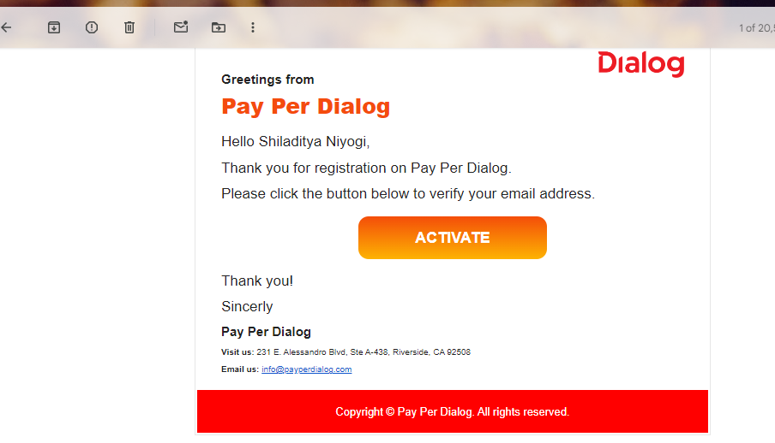

4. Looks good – may have to change the verbiage later 🡺 Please provide the content so that we can modify.

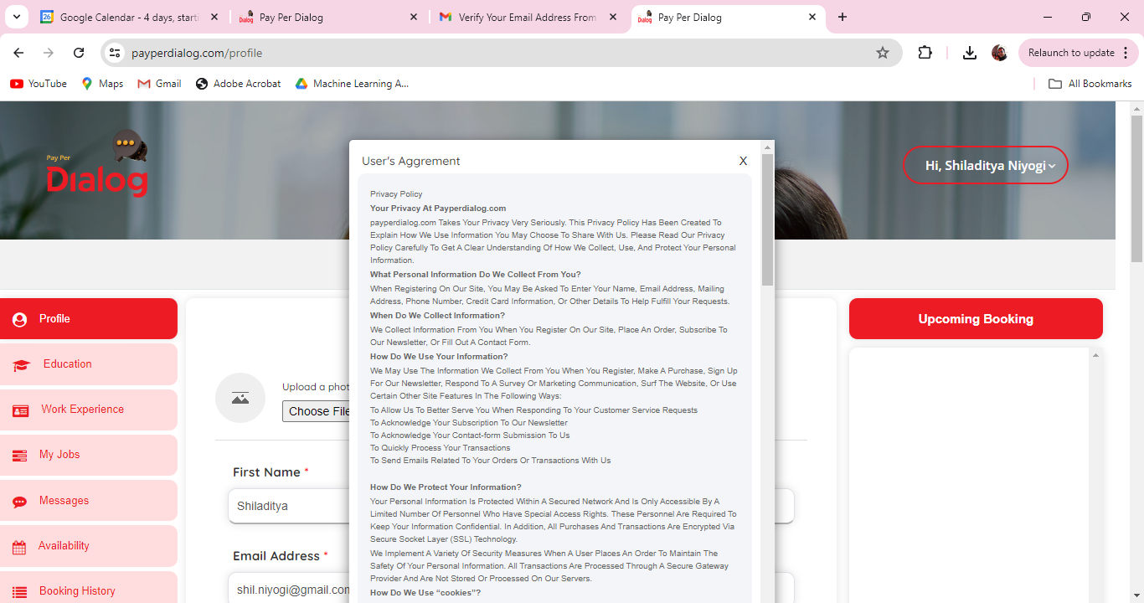

5. Will have to change the User’s agreement verbiage 🡺 Please provide the content so that we can modify.

6. This User’s agreement is coming back again and again even after I check and say Next. I had to close it by clicking on the x button. 🡺 **There will not be any close button in the agreement popup. Use need to accept agreement before proceeding. Currently in the website we have “Privacy policy” and “Terms and condition” content. We will replace that**, **once you provide “Agreement” content.**

7. Total Experience “> 10 Years” should be an option 🡺 Fixed

8. Instead of “Short Bio”, we can say “Please let us know what differentiates you as a candidate” 🡺 Fixed

9. After Saving the User’s agreement again comes up. 🡺 Fixed

10. Also, there is a type in the heading – it should be “Agreement”. 🡺 Fixed

11. BTW, the dialog box for User agreement is not dock able. Cannot see the save button till I zoom out significantly.Also, it does not let me go to the other vertical menus as there is no “x” button anymore (or is there but invisible) - education, work experience, My jobs, etc. 🡺 **There will not be any cross button in the agreement popup. Use need to accept agreement before proceed. For the current agreement “Privacy policy” and “Terms and condition” content is attach. If you can provide “Agreement” content we will replace by that**.

12. Here in the calendar, we can say “Show availability” and not “Schedule” 🡺 DONE. “Schedule” Button is to add availability for job seeker. Job Seeker can add multiple availability for a particular date.

For employer

13. I applied to the job as an employee but I do not see the applicant as an employer. It should ideally show up as an applicant. 🡺 **“My Jobs” tab is only for employer, where employer can see their posted job. Employer can see job bid list in “Applications to your jobs” tab.**

However, I show up in the ready for interview when I select “All Recommended employee” under the Skill Sets dropdown. How do we get to see this person for the job “Need AI..”? Is there a selection process before that?

**🡺 Employer will get a list of job seeker in the “Ready for interview” tab, once employer select a job bid as “Ready for interview” in “application to your jobs” tab. In this tab employer can filter job seeker by the accepted job post.**

Also, when I select the employee I am not able to select the slot I do not see available slot. **🡺 Employee needs to add slot. Once availability added by the job seeker then only it will be visible to the job seeker details page and then employer can book slot with that job seeker.**

So I go back and login as an employee – and I face that User Agreement screen *which should come only when I am signing up” 🡺 Fixed

I also see “pending” as an employee – what is that? Pending interview or rejection?

1. Pending 🡺 Initial status should be pending if job seeker bids in any job.
2. Screen Out 🡺 Functionality to reject a particular bid.
3. Screened In 🡺 Functionality to select a particular bid.
4. Ready For interview 🡺 If employer choose a jobseeker as “Ready for Interview”, that job seeker will move to the next tab “Ready for Interview”, from where employer can schedule interview for that particular job seeker.

I add another slot

Now, as an employer, I cannot double click and get into employee’s availability

Only after I logged out from my other browser as an employee, it allows me to double click and select the employee.

As an employer I went ahead and booked the candidate **🡺 Employer can see job seekers availability only from the job seeker details page once employer logged in. “Availability” tab is only visible for job seeker as only job seeker can add availability. Once employer book any slot from job seeker details page, booking list will be shown on “Booking history” tab for both the users.**

There should be an email sent or some notification. How do I start the interview as an employer or an employee?

🡺 **Fixed. User will get an email with meeting link after paying slot book.**

I don’t see a link for the interview for the employer.

When I click on the link of an employee I see this page:

